SLQ INJECTION ESSAY – SUBJECT 40

SUMMARY :

I – Introduction

II - Understanding SQL Injections

III - Types of SQL Injections

IV - Consequences of SQL Injections

V - Famous SQL Injection Attacks

VI - Methods to Prevent SQL Injections

VII – Conclusion and Diagram

***GITHUB LINK :*** [***HERE***](https://github.com/BenjiPy)

**I – Introduction**

First, it’s important to redefine what SQL means. SQL or Structured Query Language is a data management language used for interacting with databases. Introduced in the 1970s, SQL brought two significant advancements over previous methods of data access. First, it allowed the retrieval of multiple records with a single command, making data handling more efficient. Second, it abstracted the need to define how a record is accessed, such as using an index or not, simplifying database management. However, with its widespread use, SQL also became a target for attackers who exploit security vulnerabilities, leading to techniques such as SQL injection. SQL injection (SQLi) is one of the most common and dangerous vulnerabilities in web applications, capable of compromising an entire database.

**II – Understanding SQL Injections**

SQL injection is a code injection technique used by attackers to manipulate and exploit vulnerabilities in an application's interaction with its database. When an application fails to properly validate user input, it opens the door for attackers to inject malicious SQL code into queries. This allows the attacker to bypass authentication, extract sensitive information, or modify the database content.

For example, consider a basic SQL query to check user credentials:

If the application doesn’t properly sanitize user input, an attacker could modify the username field like this:

In this case, the condition '1'='1' is always true, granting unauthorized access to the system. SQL injections exploit this vulnerability, and without proper prevention techniques, they can result in severe data breaches.

**III – Types of SQL Injections**

There are several types of SQL injections, each with different levels of complexity and impact. Understanding these is crucial to implementing effective security measures.

1. **Basic SQL Injection:** This is the simplest form of SQL injection where an attacker directly inputs malicious SQL commands into a form field or URL. It can lead to unauthorized access or data leaks if no input validation is in place.
2. **Error-Based SQL Injection:** In this method, the attacker uses error messages generated by the database to gather information about the database structure. For example, error messages might reveal table names, column names, or data types, giving the attacker critical information to refine their attack.
3. **Blind SQL Injection:** In cases where the application does not return error messages or detailed information, attackers use blind SQL injection. They inject SQL code and infer whether the injection was successful based on subtle differences in the application's behavior, such as page loads or content displayed.
4. **Union-Based SQL Injection:** This type of injection uses the SQL UNION operator to combine multiple SELECT queries, allowing the

attacker to retrieve data from other tables within the database. By appending queries with UNION SELECT, an attacker can manipulate the response to include unauthorized data.

1. **Time-Based Blind SQL Injection:** This method involves sending a query that causes a time delay in the database response. By observing the time it takes for the server to respond, the attacker can determine whether their query was successful.

Each of these techniques can be highly effective depending on the security weaknesses of the application and the skill level of the attacker.

**IV – Consequences of SQL Injections**

The consequences of SQL injections can be devastating for individuals, businesses, and institutions. Below are some of the most common and severe impacts:

1. **Data Theft:** SQL injection attacks often aim to extract sensitive data from the database, including user credentials, personal information, or financial data. This can lead to identity theft, financial losses, and violations of data privacy laws such as RGPD.
2. **Data Tampering:** Attackers can manipulate or delete data within the database, causing significant disruption to business operations. For example, a successful injection could alter a company's financial records or delete key data from a customer database.
3. **Unauthorized Access:** In some cases, SQL injections allow attackers to bypass authentication mechanisms and gain administrative privileges. This level of access can enable further attacks, such as installing malware (backdoor) or escalating privileges.
4. **System Takeover:** In extreme cases, SQL injection attacks can lead to the complete compromise of a system. Attackers can execute commands on the server, modify system settings, or install malicious software.
5. **Financial and Reputational Damage:** A successful SQL injection attack can lead to significant financial losses due to legal penalties, data recovery efforts, and compensation to affected users. Moreover, the reputation of the affected organization may be severely damaged, leading to loss of customer trust.

**V – Famous SQL Injection Attacks**

SQL injection has been responsible for some of the most notorious data breaches in history. Here are a few notable examples:

1. **Heartland Payment Systems (2008):** One of the largest data breaches in history, affecting over 130 million credit card transactions. Attackers used SQL injection to gain access to the company's payment processing system, leading to widespread financial fraud.
2. **Sony Pictures (2011):** Attackers exploited SQL injection vulnerabilities to gain access to Sony’s database, leaking sensitive data, including passwords, financial information, and private emails. This led to a significant financial and reputational crisis for the company.
3. **TalkTalk (2015):** A SQL injection attack on the UK telecom company TalkTalk exposed the personal data of over 150,000 customers. The attackers accessed the company's database via a vulnerability in its website, leading to the theft of credit card information and personal details.

These examples demonstrate the widespread impact SQL injection attacks can have, highlighting the need for robust security measures to prevent such vulnerabilities.

**VI – Methods to Prevent SQL Injections**

Preventing SQL injections requires a combination of secure coding practices, database configurations, and security monitoring. Below are some of the most effective methods:

1. Une image contenant capture d’écran, texte

   Description générée automatiquement**Use of Prepared Statements (Parameterized Queries):** Prepared statements ensure that user input is treated as data and not executable code. This method separates SQL logic from user input, preventing malicious code from being executed.
2. **Input Validation and Escaping:** Always validate and sanitize user input by removing or escaping special characters (e.g., quotes, semicolons) that could be used to manipulate SQL queries.
3. **Using ORM Frameworks:** Object Relational Mapping (ORM) frameworks, such as Hibernate or Django ORM, abstract the database interaction from the raw SQL code. This reduces the risk of SQL injection by managing query construction in a secure way.
4. **Limiting Database Privileges:** Follow the principle of least privilege, ensuring that database user accounts have only the necessary permissions to perform their tasks. Restricting access can mitigate the impact of an SQL injection attack.
5. **Security Audits and Penetration Testing:** Regularly conduct security audits and penetration tests to identify and fix vulnerabilities in the application code. Automated tools like SQLMap can also help detect potential SQL injection weaknesses.
6. **Web Application Firewalls (WAF):** Deploy a Web Application Firewall to filter and monitor traffic for suspicious activity. A WAF can block common SQL injection patterns before they reach the database.

**VII – Conclusion**

In conclusion, SQL injection remains a critical threat to web application security, capable of causing widespread data breaches and system compromise. Despite its long history, many applications continue to be vulnerable due to poor coding practices and insufficient security measures. By implementing prepared statements, input validation, least privilege principles, and regular security audits, organizations can significantly reduce the risk of SQL injection attacks. As cyber threats continue to evolve, it is crucial for developers and security teams to stay vigilant and adopt proactive security measures to protect their systems and users.

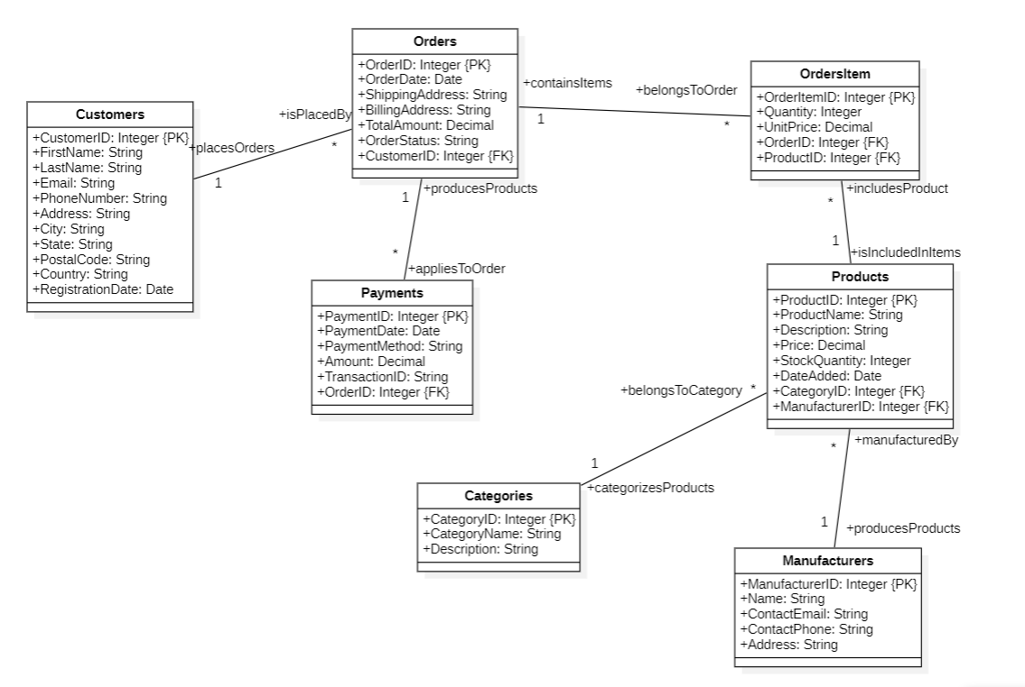**Diagram :**